

DEPARTMENT OF COMPUTER ENGINEERING

**K.K. INSTITUTE OF ENGINEERING EDUCATION AND RESEARCH, NASHIK**

CST-PROJECT BASED LEARNING

REPORT ON

**Project Domain –** Web Development

**Project Title –** First step finder-A Local Guide

## Team Memebers :

1. Aachal Patani
2. Shravani Pawar
3. Ajinkya Patil
4. Abhishek Malajangam

**Guided By –** Prof.Dr.Snehal Kamlapur

**Duration :** Feb 2024-April 2024

**Project Title :** First Step Finder-A Local guide

## Project Overview :

* In this website we have used the front end technologies like programming languages (HTML , CSS , JAVASCRIPT) .
  + HTML – It is use for structuring the elements and defining the layout of the webpages .
  + CSS – It is use for styling the webpages and making it visually appealing.
  + JAVASCRIPT – It is use to create dynamic and interactive website .

**Purpose of the website :**

To serve as the ultimate companion for newcomers navigating Nashik city, providing comprehensive information, insights, and resources tailored to enhance their experience. Our platform aims to empower newcomers by offering detailed guides on local attractions, dining hotspots, cultural events, transportation options, accommodation recommendations, and insider tips. By curating up-to-date content and fostering community engagement, we strive to alleviate the challenges of settling into a new city, making the transition seamless and enriching for every visitor.

# Tools Used :

|  |  |  |  |  |
| --- | --- | --- | --- | --- |
| **Sr.**  **No.** | **Name of**  **Resource/material** | **Specifications** | **Qty** | **Remarks** |
| 1 | Laptop | Processor: Intel(R) Core i3-2350M CPU @2.30GHz 2.30 GHz.  HDD: 500 GB  RAM: 4 GB | 01 | For preparing Micro project related word documents. |
| 2 | VsCode | Version : 1.88.1 | 01 | For studying about Micro- project related information and  details. |
| 3 | website | https://www.figma.com/login | 01 | For designing UI. |

**Survey Analysis :**

* We conducted a survey specifically for new students and new travellers to try to get an inside look into their busy lives . Their opinion founds are very interesting and helpful.
* We had made survey through circulating google form towards the new students and traveler as well as local residents.

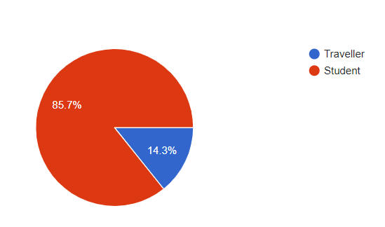

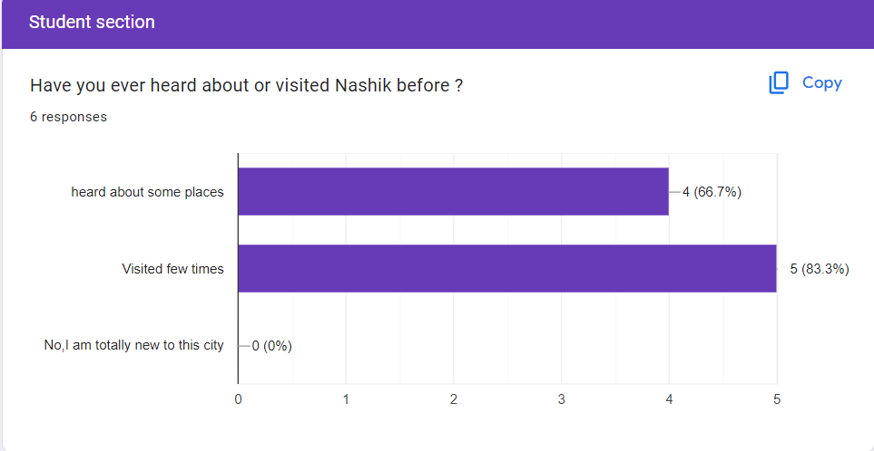

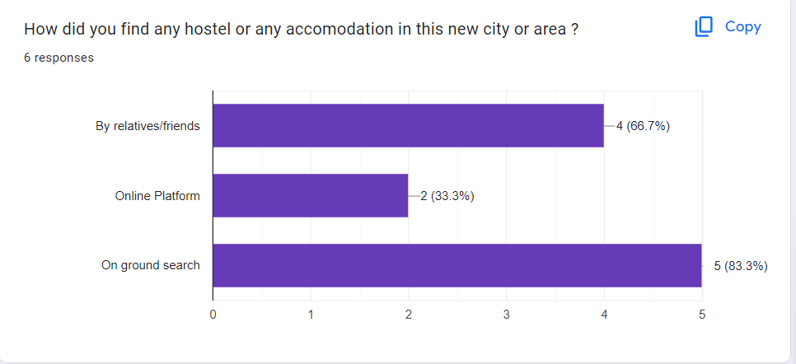

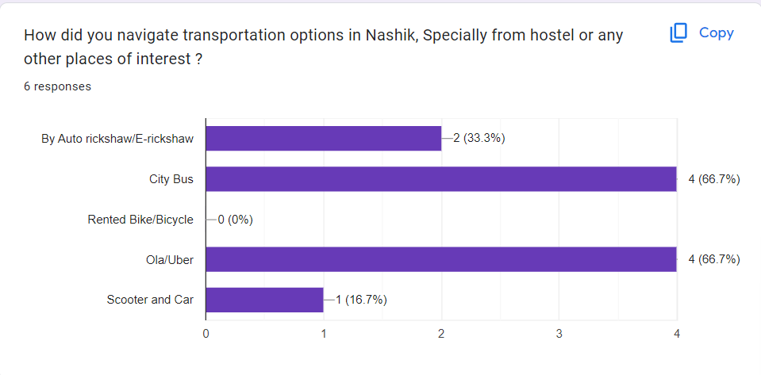

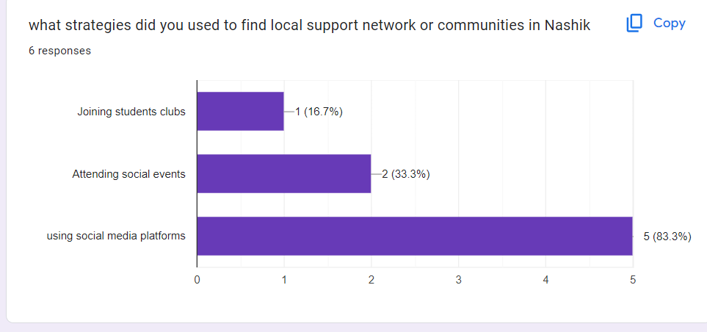

**Features of our Website :**

* City Information: Provide comprehensive information about the new city along with the popular areas like ,

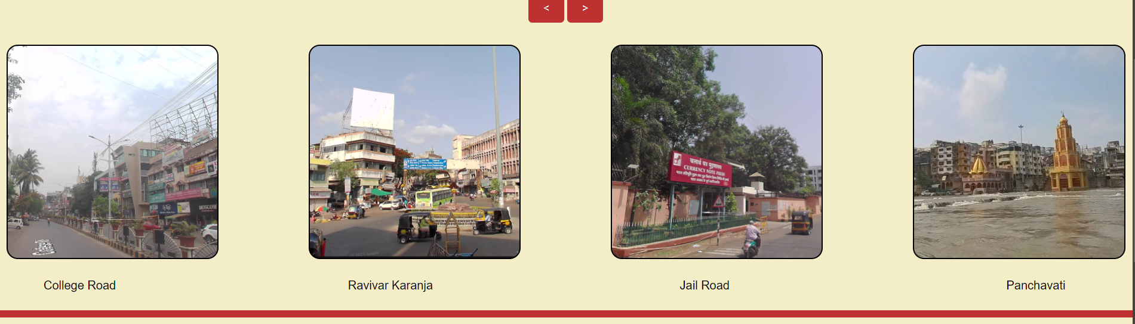

* Transportation Guide: Offer guidance on public transportation options such as buses, trains, subways, and taxis. Include maps, routes, schedules, and fare information.
* Accommodation Assistance: Offer resources and tips for finding temporary or permanent accommodation, including student housing, apartments, and roommate matching services.
* Login :

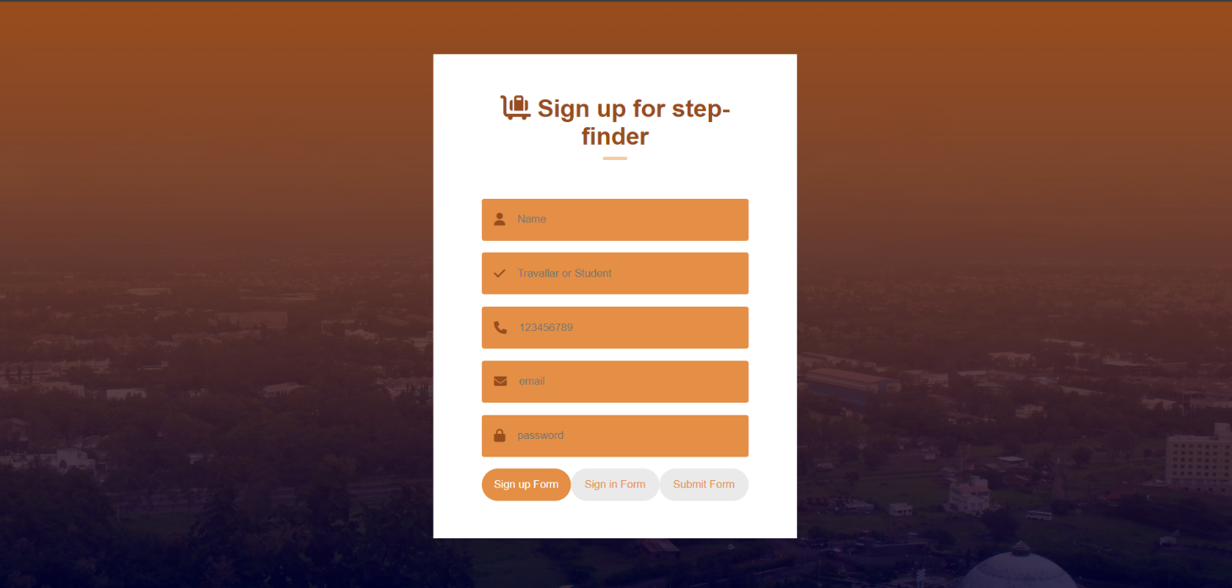

* Google Map :

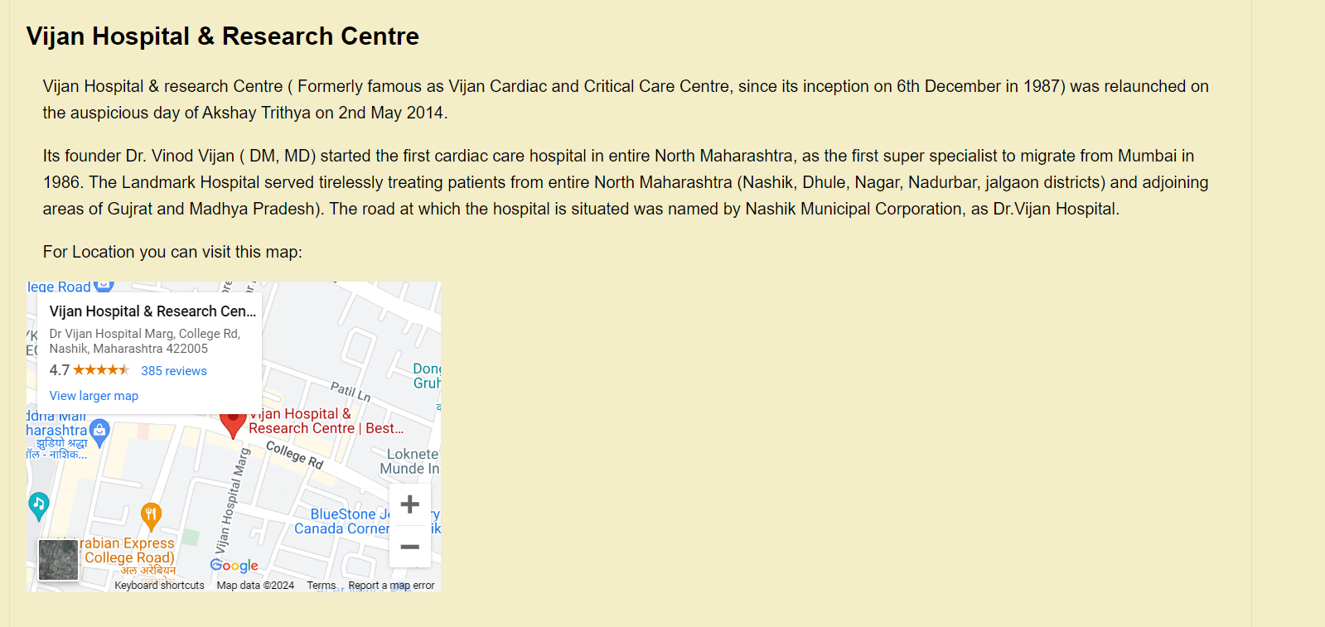

* Explore section :

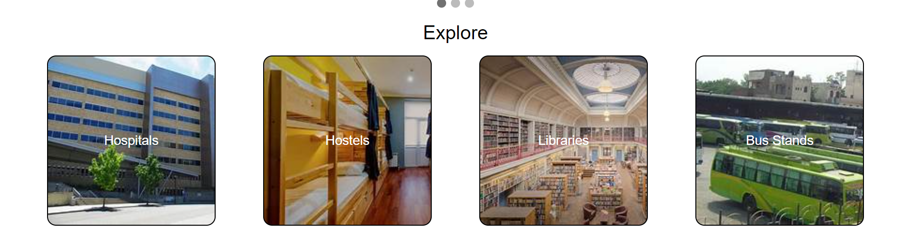

By incorporating these features, a first step finder website can serve as a valuable resource for new student visitors in a new city, helping them feel more confident and empowered as they navigate their new environment.

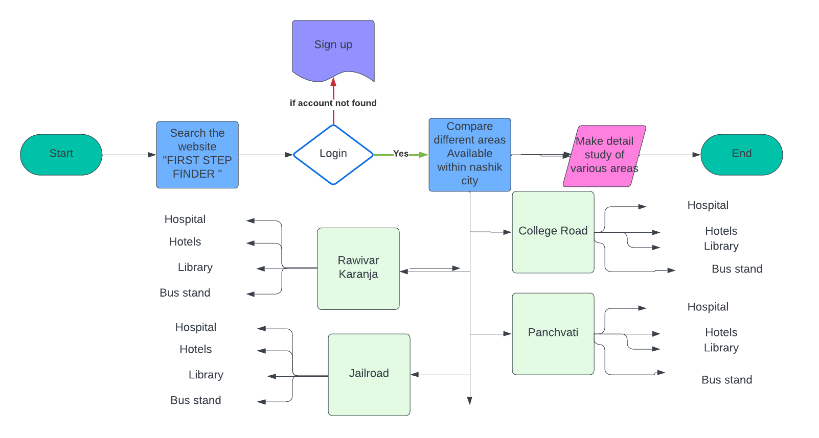**Flow Digram :**

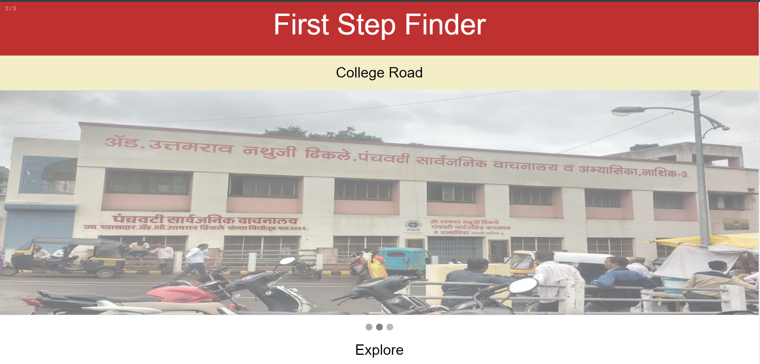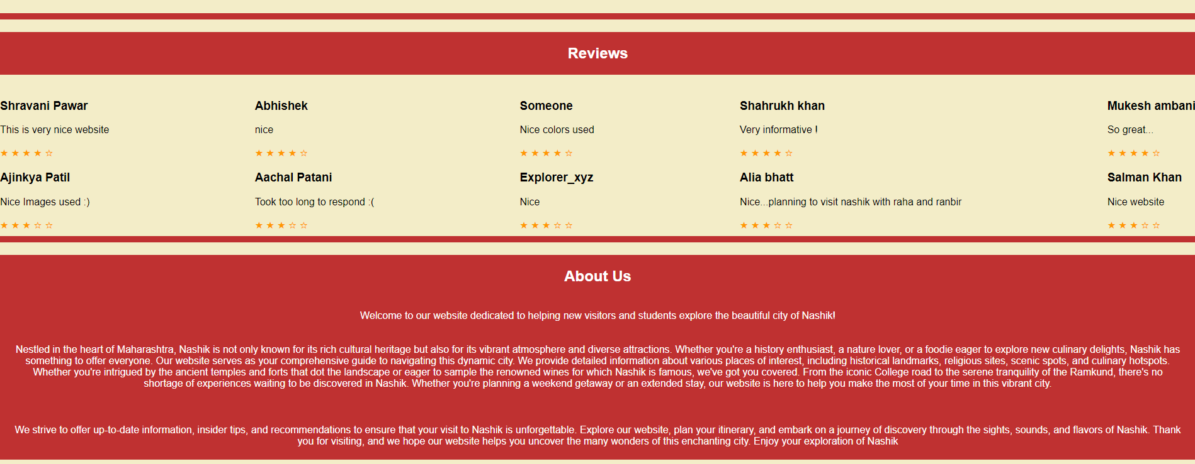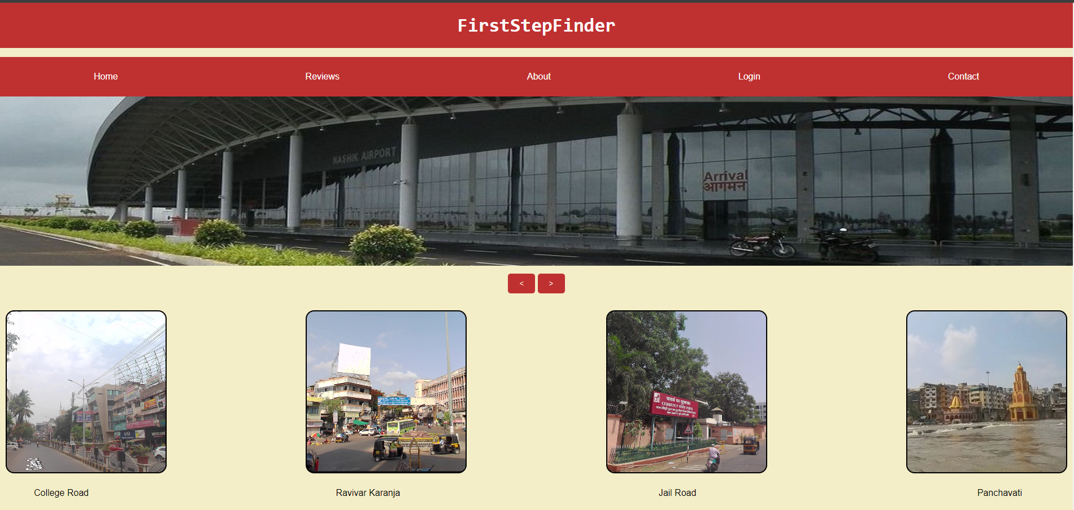**Graphical User Interface:**

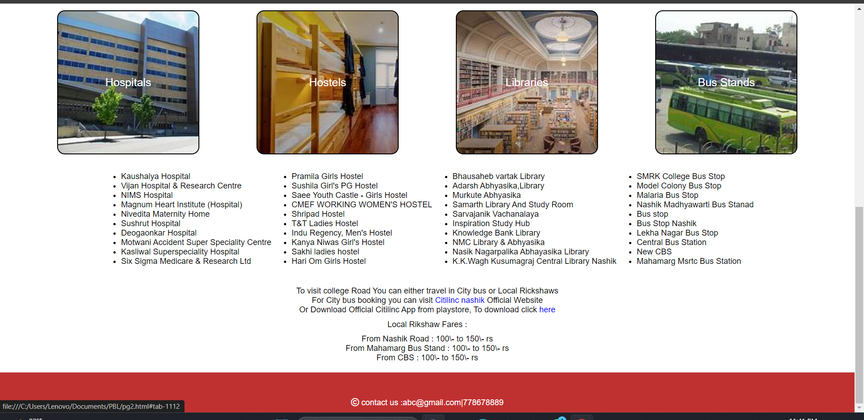

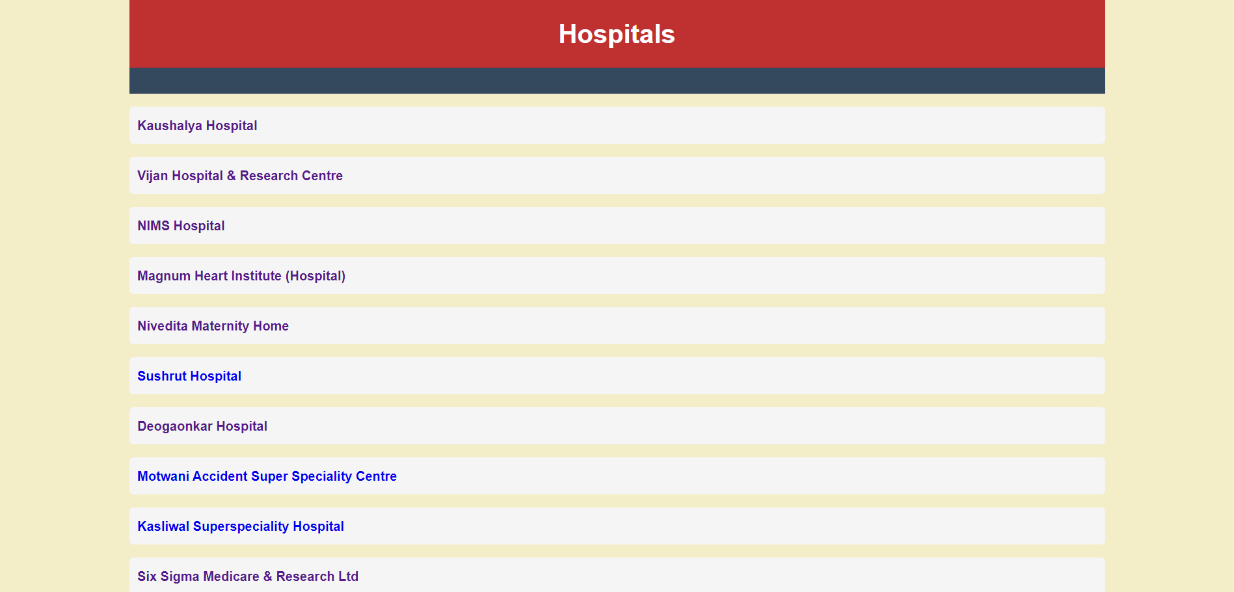

**Summary:**

Embarking on a new chapter in a new city can be exhilarating yet daunting. Fear not, for our ultimate guide is tailored to empower you through this transition. Delve into our website, meticulously crafted to equip you with indispensable knowledge and resources. Whether you're pondering transportation logistics, seeking accommodation aid, or craving insight into local services, safety measures, and coveted student discounts, consider us your steadfast companion.

Navigate our comprehensive city guides, meticulously curated to unveil hidden gems and essential landmarks, ensuring you traverse the urban landscape with confidence. But our support extends beyond mere information—we foster connections among fellow students, facilitating friendships that enrich your journey.

Embrace the unknown, for within it lies the allure of discovery and growth. With First Step Finder by your side, embark on this new adventure with assurance and enthusiasm. Welcome to your new home.

**References** :

Just Dial Website : <https://www.justdial.com/Nashik/Lodging-Services/nct-10303591>

Google maps : https://www.google.com/maps/@37.0625,-95.677068,4z

Reference places - <https://www.holidify.com/places/nasik/sightseeing-and-things-to-do.html>